

**rem**edē® System

1.5 Tesla and 3 Tesla Magnetic Resonance Imaging (MRI) Guidelines Manual

**rem**edē® Implantable Pulse Generator Model 1001, 1100, 1600

respi**stim**® L Stimulation Lead Models 2002, 2003, 2004

respi**stim**® LQ Stimulation Lead Models:

IS-1 Terminal Models: 5045 - 5085, 5145 - 5185

In line Terminal Models: 5645 - 5685

respi**stim**® LQS Stimulation Lead Models:

IS-1 Terminal Models: 4045 - 4085, 4145 - 4185

In line Terminal Models: 4645 - 4685

respi**stim**® R Stimulation Lead Models:

IS-1 Terminal Models: 3101 - 3106, 3201 - 3206

In line Terminal Models: 3601 - 3606, 3611 – 3616, 3651 - 3656

Prescription Only. U.S. Federal Law Restricts This Device to Sale by or on the Order of a Physician or Properly Licensed Practitioner

TABLE OF CONTENTS

TABLE OF CONTENTS 2

LIST OF TABLES 2

LIST OF FIGURES 2

1.1 Symbols Used on Product or Package Labeling 3

1.2 Introduction 4

1.3 Description of MR Conditional remedē System Components 5

1.3.1 **rem**edē® Patient ID card 7

1.4 Definition of Terms 7

1.5 MRI Risks Associated with the remedē System 8

1.6 Contraindications and Warnings 8

1.6.1 Contraindications 8

1.6.2 Warnings 8

1.7 MRI Center Instructions 8

1.7.1 Prior to MRI Examination 8

1.7.2 Preparing a Patient for an MRI Scan 9

1.7.3 Additional Information 9

1.8 MRI Conditions for Use with the remedē System 10

1.8.1 General Requirements 10

1.8.2 MRI Scanning 11

1.8.3 Coil Positioning Restriction Zones 12

1.9 Considerations during the MRI examination 14

1.10 Considerations after the MRI examination 14

LIST OF TABLES

Table 1 remedē System components that are eligible for Whole-body MRI scans and Head Scan (1.5T and 3T) under specified conditions. 5

Table 2 Off-the-shelf components that are eligible for Whole-body and Head MRI scans (1.5T and 3T) when used with the remedē System under specified conditions. 6

Table 3 Components of the remedē System that are MR Unsafe 7

Table 4 remedē System MRI Scanning Conditions 11

Table 5 1.5T Operating Mode Scan Time Restrictions per Zone 13

Table 6 3T Operating Mode Scan Time Restrictions per Zone 13

LIST OF FIGURES

Figure 1 Coil Position Restriction Zones 12

Figure 2 Example of Programmer alert when device has entered in Safe mode 14

[Figure 3 Summary Tab Operating Mode display when Implantable Device is   
 in Safe Mode 14](#_Toc128550183)

## Symbols Used on Product or Package Labeling

Refer to individual product for applicable symbols.

|  |  |
| --- | --- |
|  | Applies to U.S. audiences only |
| http://www.signatureortho.com.au/repository/Problabels/ProductLabels-Ref.jpg | Catalog or Reference Number |
| http://www.fertipro.com/images/symbols/LOT.jpg | Lot Number |
| Sterilized Using Ethylene Oxide | Sterilized using ethylene-oxide gas |
|  | Sterile Lot Number |
| http://www.fridays-instruments.com/2logo.jpg | Do Not Reuse/Single Use Only |
|  | Do Not Resterilize |
|  | Temperature Limitation/Temperature Range |
| Caution | Caution |
|  | MR Unsafe |
|  | MR Conditional |
| https://www.cookmedical.com/wp-content/themes/cookmedical_bootstrap/img/content/product-labels/content-icon-expiration-date.png?905860 | Use by/Expiration date |
| http://www.fertipro.com/images/symbols/date_of_manufacture.jpg | Date of Manufacture |
|  | Manufacturer |
|  | Quantity in Package |
|  | Inside Diameter |
| C:\Users\tgoblish\AppData\Local\Microsoft\Windows\Temporary Internet Files\Content.Outlook\140CNKT1\outer diameter-01.jpg | Outside Diameter |
|  | Length |
| http://www.fertipro.com/images/symbols/read_ifu.jpg | Consult Instructions for Use |
| Keep Away from SunlightKeep Dry | Keep away from heat and keep dry |
|  | Non-ionizing electromagnetic radiation |
| http://www.technicalscribe.net/resources/fcc.gif | Federal Communications Commission notice (USA) |
| Prescription Only. U.S. Federal Law Restricts This Device to Sale by or on the Order of a Physician or Properly Licensed Practitioner | Use by prescription only |

## Introduction

These guidelines are a supplement to the **rem**edē System Implant and Clinician Use Manual for using 1.5T and 3T horizontal cylindrical (closed bore) MRI systems for patients implanted with the **rem**edē System. Magnetic Resonance Imaging (MRI) is a tool used to diagnose various diseases and conditions. MRI uses a powerful static magnetic field, gradient magnetic fields and RF energy to construct an image of a section of the body.

Tests have shown that patients implanted with the **rem**edē System can be safely exposed to MR environments specified in this guideline. However, MR scans performed outside these guidelines may result in the MRI field interacting with the implanted devices, potentially injuring the patient, and damaging the implanted device. Due to risks associated with using an MRI with an implanted device, it is important to read, understand and comply with these instructions to prevent potential harm to the patient and/or damage to the device.

The implantable components of the **rem**edē System are MR Conditional devices that demonstrate no known hazards in a specified MR environment when following specific guidelines as outlined in this document. The **rem**edē System implantable components consist of an implantable pulse generator (IPG), one transvenous lead to stimulate the phrenic nerve, and one optional transvenous sensing lead to sense respiration via transthoracic impedance (sensing lead compatible with Model 1001/1100 IPG only). It is IMPORTANT to read this full document prior to conducting or recommending an MRI examination on a patient with the **rem**edē System. These instructions only apply to the **rem**edē System and do not apply to other products. The current version of these guidelines can be found at remede.zoll.com.

## Description of MR Conditional remedē System Components

The following tables provide the model numbers of components that may comprise an MR Conditional **rem**edē System.

Table 1 remedē System components that are eligible for Whole-body MRI scans and Head Scan (1.5T and 3T) under specified conditions.

|  |  |
| --- | --- |
| **Component** | **Model Number(s)** |
| **rem**edē IPG | 1001, 1100, 1600 |
| respi**stim** Left Stimulation Lead | L Lead Models – 2002, 2003, 2004  LQ Lead Models – 50XX, 51XX, 56XX  LQS Lead Models – 40XX, 41XX, 46XX  Where “XX” denotes Lead Length in cm (45, 55, 65 or 85 cm) |
| respi**stim** Right Stimulation Lead | R Lead Models - 3101–3106, 3201–3206, 3601–3606, 3611–3616, 3651-3656 |

Table 2 Off-the-shelf components that are eligible for Whole-body and Head MRI scans (1.5T and 3T) when used with the remedē System under specified conditions.

|  |  |
| --- | --- |
| **Component Description** | **Use Considerations** |
| Bipolar Sensing Lead with IS-1 terminal and co-radial coil | The **rem**edē Model 1001 / 1100 IPGs were evaluated to be MR Conditionally safe using an off-the-shelf, IS-1 bipolar lead with co-radial coil connected to the IPG sensing port. However, prior to an MRI examination, determine whether the patient has a sensing lead inserted into the **rem**edē Model 1001 / 1100 IPG sensing port. If so, the MR labeling of the sensing lead must be determined and the most restrictive MRI exposure requirements must be used of the medical device implants. Contact the appropriate device manufacturers if you have questions. If you are unclear what implants may be present, perform an x-ray to determine implant type and location. Do not conduct an MRI examination if any conditions or implants that would prohibit or contraindicate an MRI are present. |
| IS-1 Port Plug (3.5cm) with metallic contacts | The **rem**edē Model 1001 / 1100 IPGs were evaluated to be MR Conditionally safe using an off-the-shelf, IS-1 port plug (3.5 cm in length) with metallic contacts inserted into the IPG sensing port. However, prior to an MRI examination, determine whether the patient has an IS-1 port plug inserted into the **rem**edē Model 1001 / 1100 IPG sensing port. If so, ensure the IS-1 port plug is no greater than 3.5cm in length or has MR conditional approval. Contact the appropriate device manufacturers if you have questions. If you are unclear what implants may be present, perform an x-ray to determine implant type and location. Do not conduct an MRI examination if any conditions or implants that would prohibit or contraindicate an MRI are present. |

The following table lists components of the **rem**edē System that are MR Unsafe. **Do not bring these components into the MR scanner room.**

Table 3 Components of the remedē System that are MR Unsafe

|  |  |
| --- | --- |
| **Component** | **Model Number(s)** |
| Physician Programmer | 1002A |
| Programming Wand | 1004A, 1004A-F |
| EIPG | 1006, 1006A |
| Lead Adapter | 1007 |



### remedē® Patient ID card

Advise the patient to bring the most up-to-date patient ID card to all MRI appointments. MRI personnel can then use the patient ID card to identify Respicardia as the manufacturer of the patient’s implantable system.

## Definition of Terms

* ***MR Conditional***: An item with demonstrated safety in the MR environment within defined conditions. At a minimum, address the conditions of the static magnetic field, the switched gradient magnetic field and the radiofrequency fields. Additional conditions, including specific configurations of the item, may be required.
* ***Radio frequency (RF) magnetic field***: The magnetic field in MRI that is used to flip the magnetic moments.
* ***Specific absorption rate (SAR)***: Radiofrequency power absorbed per unit of mass (W/kg).
* ***B1+RMS*:** Time averaged B1+ field measured in micro-Tesla (μT).
* ***Tesla (T)***: The SI unit of magnetic induction equal to 104 gauss (G).
* ***Integrated Body Coil***: The coil built-in to the MRI system that functions both as transmit and received coil and can be used as transmit-only integrated body coil in conjunction with receive-only local coils.
* ***Transmit/Receive head coil***: A coil used to transmit and receive RF energy that is limited to the head only.
* ***Transmit/Receive local coil***: A coil used to transmit and receive RF energy that is limited to a section of the body only (e.g. knee coil).
* ***Concomitant implanted device***: Any other implantable product, active or inactive. (e.g. implantable device for treatment of obstructive sleep apnea, cardiac stimulators and monitors, stimulators for pain, etc.)

## MRI Risks Associated with the remedē System

The potential risks of performing MRI on patients implanted with the **rem**edē System include:

* Device movement
* Excessive heating of or around the implanted device components
* Tissue damage
* Damage to the device
* Device interactions
* Uncomfortable sensation
* Image artifact

## Contraindications and Warnings

### Contraindications

Do notuse MRI systems that are vertical field (open bore) or are operating at static magnetic field strengths other than 1.5T or 3T. The risks of using MRI systems operating at static magnetic field strengths other than 1.5T or 3T have not been determined and could be significant.

### Warnings

**Other implanted devices –** Prior to an MRI examination, determine whether the patient has multiple medical device implants, either active medical device implants (such as deep-brain stimulation systems, implantable cardiac defibrillators, etc.) or passive medical device implants (such as spinal hardware, stents, etc.). The most restrictive MRI exposure requirements must be used of the medical device implants. Contact the appropriate device manufacturers if you have questions. If you are unclear what implants may be present, perform an x-ray to determine implant type and location. Do not conduct an MRI examination if any conditions or implants that would prohibit or contraindicate an MRI are present.

## MRI Center Instructions

### Prior to MRI Examination

The following steps shall be performed by the MRI center when scheduling the scan with the patient.

**Step 1: Confirm that the patient’s implanted remedē System components are MR Conditional (see Table 1 and Table 2).**

**Step 2: Check if the patient has any other medical device implants.**

The most restrictive MRI exposure requirements must be used if the patient has multiple medical device implants. Consult with the manufacturers of the devices.

**Step 3: What to bring the day of the MRI scan.**

Inform the patient to bring their patient ID card to the MRI scan.

### Preparing a Patient for an MRI Scan

Before conducting an MRI scan, the following steps must be performed. If there are questions about these instructions, do NOT scan the patient and contact Respicardia Technical Services.

**Step 1: Confirm that the patient has brought their patient ID card.**

**Step 2: Confirm that the patient’s implanted remedē System components are MR Conditional (Table 1 and Table 2).**

**Step 3: Check if the patient has any other medical device implants.**

The most restrictive MRI exposure requirements must be used if the patient has multiple medical device implants. Consult with the manufacturers of the devices.

**Step 4: Do NOT conduct an MRI scan if there are abandoned respistim leads**

**Step 5: Document the patient’s therapy settings**

Interrogate the **rem**edē IPG and store the patient’s therapy settings. This information may be used for restoring the patient’s therapy following an MRI scan.

**Step 6: Perform a stimulation lead impedance check of all electrodes using the Physician Programmer.**

**Do NOT** perform an MRI scan if the impedance check provides a warning indicating any impedance is out of range.

**Step 7: Program Mode to OFF.**

**Step 8: Perform the MRI scan per the requirements in the following sections.**

### Additional Information

* A trained professional with the proper knowledge of MRI equipment such as an MRI-trained radiologist or MRI physicist must ensure the MRI examination will be conducted according to the information outlined in this document.
* Inform the patients of all the risks associated with undergoing an MRI examination as stated in this document.
* Always consult with the physician responsible for managing the patient’s **rem**edē system.
* If possible, do not sedate the patient, so the patient can inform the MRI operator of any problems during the examination.
* Instruct the patient to immediately inform the MRI operator if any discomfort, stimulation, shocking or heating is experienced during the examination.
* MRI images near implanted devices may contain image artifacts. Contact Respicardia for additional information about the expected extent and appearance of the image artifact under various scan conditions.

## MRI Conditions for Use with the remedē System

The MRI examinations described below can be safely conducted in patients with the **rem**edē System if all the instructions in this document are followed. Non-clinical testing has shown the **rem**edē System is MR Conditional. A patient with this system can be safely scanned using 1.5T and 3T MR scanners meeting the following conditions.

### General Requirements

Verify the following with the patients’ physician, referring medical facility, implanting physician or a Respicardia representative.

* The **rem**edē System components listed in **Table 3** are MR Unsafe and should not be allowed into the MRI scan (magnet) room.
* Do not perform MR scan if the patient is implanted with a **rem**edē System component not listed in **Table 1** above.
* Ensure the steps listed in section 1.7 (MRI Center Instructions) are completed.
* Do not cover the patient with blankets or heated blankets. Blankets raise the patient’s body temperature and increase the risk of tissue heating, which could cause tissue damage.

### MRI Scanning

MRI scans can be safely conducted in patients implanted with the **rem**edē System using 1.5T and 3T MR scanners if the following conditions in **Table 4** are met:

Table 4 remedē System MRI Scanning Conditions

|  |  |
| --- | --- |
| MRI Safety Information  A person implanted with the **rem**edē Implant System may be safely scanned anywhere in the body at 1.5T or 3.0T under the following conditions. Failure to follow these conditions may result in injury. | |
| **Parameter** | **Condition** |
| Device Name | **rem**edē IPG*  respi**stim** Lead*  Sensing Lead**  IS-1 Port Plug with metallic contacts**  \**see* ***Table 1*** *for component description*  \*\**see* ***Table 2*** *for component description* |
| Device Configuration | Mode: OFF |
| Static Magnetic Field Strength (B0) | 1.5T and 3T |
| MR Scanner Type | Cylindrical |
| B0 Field Orientation | Horizontal |
| Maximum Spatial Field Gradient | 19.1 T/m (1910 gauss/cm) |
| Maximum Gradient Slew Rate | 200 T/m/s per axis |
| RF Excitation | Circularly Polarized (CP) |
| RF Transmit Coil Type | Integrated Whole Body Transmit Coil, Head Coil |
| Operating Mode | See diagrams and Table 5 & 6 below (section 1.8.3) |
| RF Conditions |
| Scan Duration & Zones |
| Image Artifact | The presence of the **rem**edē Implant System may produce an image artifact of 7.8 cm at the IPG and 1.4 cm at the distal end of the lead. Some manipulation of scan parameters may be needed to compensate for the artifact. |

### Scan Duration and Zones - Coil Positioning Restrictions

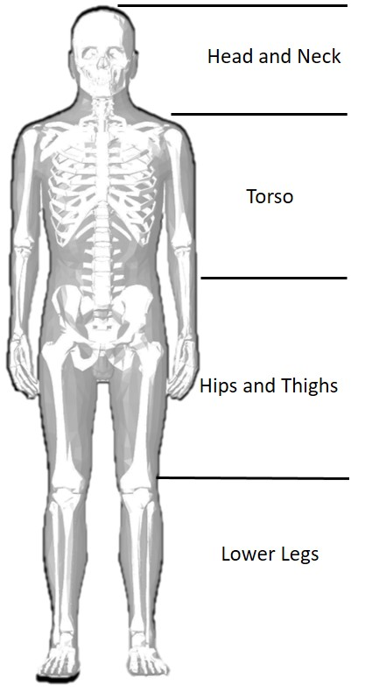MRI scans can be safely conducted in the four zones indicated in **Figure 1** below in patients implanted with the **rem**edē System using 1.5T and 3T MR scanners if the scan time conditions in either **Table 5** (1.5T Scans) or **Table 6** (3T Scans) are met.

Figure 1 Coil Position Restriction Zones

Table 5 1.5T Operating Mode Scan Time Restrictions per Zone

|  |  |  |  |  |  |  |  |
| --- | --- | --- | --- | --- | --- | --- | --- |
| **Field Strength** | **Zone** | **Normal Operating Mode\*** | | **Whole Body SAR Level: 1 W/kg** | | **Whole Body SAR Level: 0.5 W/kg** | |
| **Active Scan Time** | **Wait Time** | **Active Scan Time** | **Wait Time** | **Active Scan Time** | **Wait Time** |
| **(minutes)** | **(minutes)** | **(minutes)** | **(minutes)** | **(minutes)** | **(minutes)** |
| **1.5T** | **Head & Neck** | 4 | 12 | 8.5 | 12 | 17 | 12 |
| **Torso** | 4 | 12 | 8.5 | 12 | 17 | 12 |
| **Hips & Thighs** | Active RF Scan Time is 60 minutes in a 75-minute time period. | | | | | |
| **Lower Legs** |

*SAR limits of Normal Operating Mode as defined in IEC 60601-2-33:2022 (Ed 4.0) (Table 201.104): Whole Body SAR: 2 W/kg, Head SAR: 3.2 W/kg, Partial Body SAR: 2-10 W/kg.

Table 6 3T Operating Mode Scan Time Restrictions per Zone

|  |  |  |  |  |  |  |  |
| --- | --- | --- | --- | --- | --- | --- | --- |
| **Field Strength** | **Zone** | **Normal Operating Mode\*** | | **Whole Body SAR Level: 1 W/kg** | | **Whole Body SAR Level: 0.5 W/kg** | |
| **Active Scan Time** | **Wait Time** | **Active Scan Time** | **Wait Time** | **Active Scan Time** | **Wait Time** |
| **(minutes)** | **(minutes)** | **(minutes)** | **(minutes)** | **(minutes)** | **(minutes)** |
| **3T** | **Head & Neck** | 2 | 12 | 4.5 | 12 | 9.5 | 12 |
| **Torso** | 2 | 12 | 6 | 12 | 12 | 12 |
| **Hips & Thighs** | 15 | N/A** |  | | | |
| **Lower Legs** | Active RF Scan Time is 60 minutes in a 75-minute time period. | | | | | |

*SAR limits of Normal Operating Mode as defined in IEC 60601-2-33:2022 (Ed 4.0) (Table 201.104): Whole Body SAR: 2 W/kg, Head SAR: 3.2 W/kg, Partial Body SAR: 2-10 W/kg.

** The wait time is not applicable since consecutive 3T scans are not permitted in the Hips & Thighs zone.

## Considerations during the MRI examination

Carefully monitor the patient throughout the MRI examination both visually and audibly. Discontinue the MRI examination immediately if the patient cannot respond to questions or reports any problems.

## Considerations after the MRI examination

The patient’s physician, referring medical facility, implanting physician or Respicardia representative, shall perform the following:

* Interrogate the IPG and, if applicable, restore the IPG to pre-MRI settings.
* The **rem**edēSystem may enter into Safe Mode in the presence of a very large magnetic field such as an MRI machine. Upon IPG interrogation, the **rem**edē System Programmer will display an alert indicating the device has reverted to a secure mode (see example in **Figure 2**). The Implantable Device information on Programmer Summary tab will also list the Operating Mode as Safe as shown in **Figure 3** below.
* Please contact your Respicardia representative if the **rem**edē IPG has entered into Safe Mode. The representative will return the IPG to normal operation and confirm proper functioning.

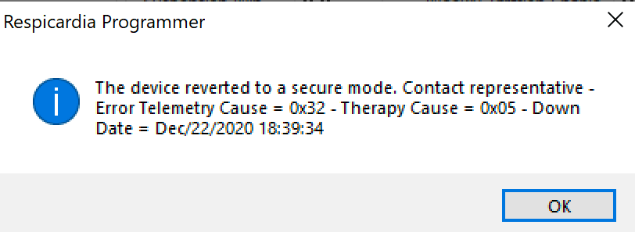

Figure 2 Example of Programmer alert when device has entered in Safe mode

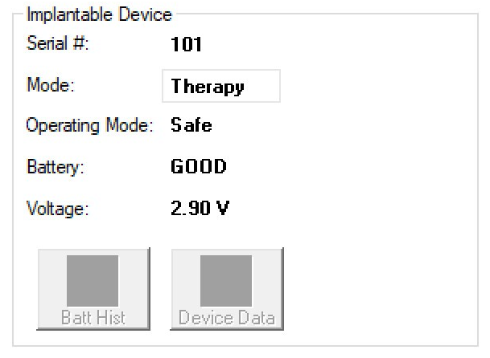

Figure 3 Summary Tab Operating Mode display when Implantable Device is in Safe Mode

**ZOLL Respicardia, Inc.**

12400 Whitewater Drive, Suite 150

Minnetonka, MN 55343 USA

Phone: (952) 540-4470

Fax: (952) 540-4485

E-mail: info@remede.zoll.com

[remede.zoll.com](http://www.cardiacconcepts.com)

The information in this document can be changed without previous warning. No part of this manual may be reproduced or transmitted in any way or by any means, either electronic or mechanical, for any purpose without explicit written allowance by ZOLL Respicardia, Inc.

ER1400, Revision A