Central Sleep Apnea and Heart Failure
Fact Sheet

WHAT IS SLEEP DISORDERED BREATHING? ^{1,2}
Sleep is a time for body and mind to rest and recuperate, an indispensable time for maintaining or improving health. Many patients with chronic health problems rarely get sufficient, quality, or restful sleep. Sleep Disordered Breathing (SDB), or disrupted breathing is a condition that disturbs the normal breathing pattern during sleep and may have an adverse effect on overall respiratory and cardiovascular health.
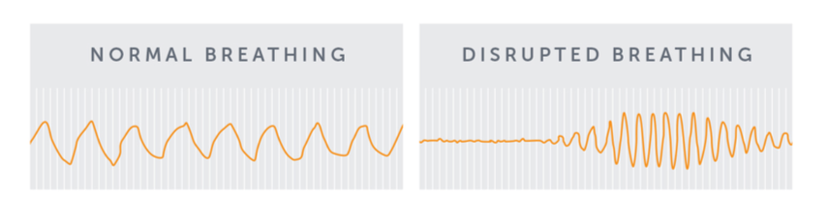
WHAT IS CENTRAL SLEEP APNEA? ^{1,2}
Central Sleep Apnea (CSA) is a serious type of sleep-disordered breathing and occurs when the brain does not send the correct signals to the breathing muscles (the diaphragm). When the diaphragm does not move properly, the lungs do not have a consistent rhythm and breathing becomes irregular. Sleep disordered breathing can be deep and rapid, slow and shallow, or breathing may stop momentarily before restarting.
CSA can lead to excessive daytime sleepiness, fatigue, hypoxia (decrease in blood oxygen level), and irregular or very fast heart rhythms (arrhythmia)¹. Studies have shown that untreated CSA is a significant contributor to lowered quality of life and contributes to poor cardiovascular outcomes.¹ CSA frequently occurs among people who have other chronic diseases such as chronic heart failure and/or atrial fibrillation.¹
An existing therapy used for CSA, continuous positive airway pressure (CPAP), is a device that delivers positive pressure through a mask worn by the patient while sleeping. This therapy can be effective but is often not well tolerated by patients and can have significant limitations that may negatively impact cardiovascular health. Some patients find it difficult to adhere to this therapy over time. ¹ All treatment options should be discussed with a physician to better understand the risks and benefits of each type of therapy.
CSA and Heart Failure ^{1,2}

According to the Heart Failure Society of America, heart failure affects over 6.5 million people in the U.S. and over 26 million worldwide.^{3,4} Heart failure occurs when the heart is unable to pump enough blood to meet the body’s demands, usually due to the heart’s inability to contract or relax properly.
CSA is common in cardiac patients, primarily those with heart failure.¹ CSA causes a repeating cycle of disruptive breathing, nighttime wakefulness and increased activation of the body’s sympathetic nervous system (“fight or flight response”) that contribute to heart failure.¹
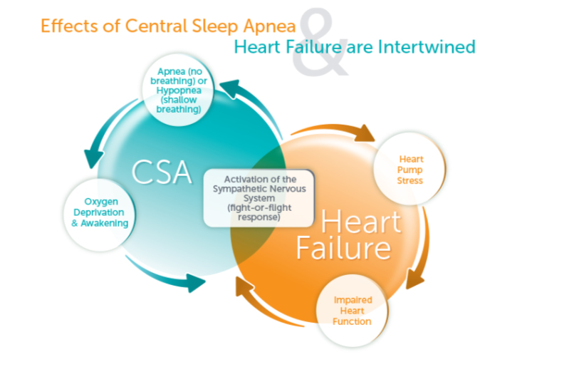
Quick Facts:
- Heart Failure affects nearly 6.5 million people in the United States and over 26 million worldwide ^{3,4}
- Central Sleep Apnea (CSA) occurs in approximately 1 in 3 HF patients and has shown to be an independent predictor of mortality for this patient population ^{5,6}
- CSA leads to decreased oxygen and increased sympathetic drive which is associated with worsening HF and death ⁷
- 1 in 3 patients hospitalized for heart failure have CSA and 50% are readmitted to the hospital at 6 months ⁸
- People with HF or heart rhythm disorders such as atrial fibrillation are at an increased risk of CSA ⁷
- ~ 30% of atrial fibrillation patients have CSA ⁹

PROVEN CSA TREATMENT
The remedē® System is an implantable therapy that monitors and stabilizes the breathing pattern to restore sleep throughout the night. The remedē® System stimulates a nerve in the chest (phrenic nerve) that sends signals to the large muscle that controls breathing (the diaphragm). These signals stimulate breathing in the same way that the brain signals breathing. It has been shown to improve sleep, breathing and quality of life for adult patients with moderate to severe CSA.¹⁰
Quick Facts
In a clinical study, the remedē® System has been shown to significantly reduce the effects of CSA
- 89% of patients had a reduction in the number of sleep apnea events¹⁰
- 78% of patients had an improvement in quality of life¹⁰
- 95% of patients reported they would “elect to have the medical procedure again”¹⁰
- Patients treated with remedē® System demonstrated clinically significant reduction in daytime sleepiness¹⁰

The remedē System received U.S. Food and Drug Administration (FDA) approval in October of 2017.

PIVOTAL TRIAL DATA SUPPORTS SAFETY, EFFECTIVENESS, AND QUALITY OF LIFE IMPROVEMENTS WITH THE remedē® SYSTEM
The remedē® System Pivotal Trial was a prospective, multi-center, randomized (1:1) controlled trial that enrolled patients with moderate to severe CSA based on polysomnographs (in-lab sleep study) scored by a blinded core laboratory. The results of the Pivotal Trial demonstrate the remedē® System therapy was safe and effective with all primary and hierarchically tested secondary endpoints met.¹¹ Treatment effectiveness and quality of life improvements were sustained at 12 months.¹⁰
Long term follow-up data out to five years was published in 2021, continuing to show the effectiveness and safety of the therapy.¹²

IMPORTANT SAFETY INFORMATION
The remedē System is indicated for moderate to severe Central Sleep Apnea in adult patients.
Your doctor will need to evaluate your condition to determine if the remedē System is right for you. You will not be able to have an MRI or diathermy (special heat therapies) if you have the remedē System implanted. The remedē System may be used if you have another stimulation device such as a heart pacemaker or defibrillator; special testing will be needed to ensure the devices are not interacting.
As with any surgically implanted device, there are risks related to the surgical procedure itself which may include, but are not limited to, pain, swelling, and infection.
Once the therapy is turned on, some patients may experience discomfort from stimulation and/or from the presence of the device. The majority of these events are resolved either on their own or by adjusting the therapy settings. The remedē System may not work for everyone. There are additional risks associated with removing your system. If you and your doctor decide to remove the system, another surgery will be required.
Be sure to talk with your doctor so that you thoroughly understand all of the risks and benefits associated with the implantation of the remedē System. Rx only. For further information, please visit remede.zoll.com, call +1-952-540-4470 or email info@remede.zoll.com.

REFERENCES
1. Costanzo MR, Khayat R, Ponikowski P, et al. State-of-the-art review: Mechanisms and clinical consequences of untreated central sleep apnea in heart failure. J Am Coll Cardiol. 2015;65:72-84.
2. Bekfani T and Abraham WT. Current and future developments in the field of central sleep apnea. Europoace, 2016;181123-1134.
3. A Report From the American Heart Association - Circulation. 2017;135:00–00. DOI: 10.1161/CIR.0000000000000485.
4. Global Public Health Burden of Heart Failure: Cardiac Failure Review 2017;3(1):7–11. DOI: 10.15420/cfr.2016:25:2.
5. Oldenburg O, Lamp B, Faber L, et al. Sleep-disordered breathing in patients with symptomatic heart failure. A contemporary study of prevalene in and characteristics of 700 patients. Eur J heart Fail 2007;9:251-7.

6. Khayat R, Jarjoura D, Porter K, et al. Sleep disordered breathing and post-discharge mortality in patients with acute heart failure. Eur Heart J. 2015;36(23):1463-9.

7. Javaheri S, Dempsey JA. Central Sleep apnea. Compr Physiol 3:141-163; Constanzo JACC.

8. Khayat R, Abraham WT, and Patt B. Central Sleep Apnea is a Predictor of Cardiac Readmission in Hospitalized Patients With Systolic Heart Failure. J Card Fail 2012; 18:534-540.

9. Bitter T, Faber L, Hering D, et al. Sleep-disordered breathing in heart failure with normal left ventricular ejection fraction. Eur J Heart Fail. 2009,11:602-608.

10. Costanzo, M. R., Ponikowski, P., Javaheri, S., et al. Sustained Twelve Month Benefit of Phrenic Nerve Stimulation for Central Sleep Apnea. The American Journal of Cardiology. 2018; DOI:10.1016/j.amjcard.2018.02.022.
11. Costanzo M, et al. Transvenous neurostimulation for central sleep apnoea: a randomised controlled trial. The Lancet. 2016; 388: 974–82
12. Costanzo MR, Javaheri S, Ponikowski P, et al. Transvenous Phrenic Nerve Stimulation for Treatment of Central Sleep Apnea: Five-Year Safety and Efficacy Outcomes. Nat Sci Sleep. 2021;13:515-526

