Improving Sleep for Patients with Central Sleep Apnea

<INSERT FACILITY NAME> is among the first hospitals in <INSERT STATE, REGION OR CITY NAME> to offer patients the remedē® System, a treatment that has been shown to improve sleep, breathing and quality of life in adult patients with moderate to severe central sleep apnea (CSA). People with moderate to severe CSA often suffer from chronic fatigue, daytime sleepiness, and memory or concentration problems.¹

<Insert a quote attributed to the implanting physician. Potential quote is below or insert your own quote. >

“The remedē® System provides physicians with an innovative therapy for patients with moderate to severe central sleep apnea,” said <PHYSICIAN>, M.D., at <HOSPITAL>. “This therapy has been proven to reduce the number of sleep apnea events which will improve daytime sleepiness and quality of life.”

Central sleep apnea is a serious type of sleep-disordered breathing that occurs when the brain does not send the correct signals to the breathing muscles (the diaphragm). The result is an inconsistent breathing rhythm and pattern, leading to repeated arousals from sleep, drops in oxygen levels in the blood, and increased cardiac stress response. For the approximately 75% of CSA patients that have heart failure and/or atrial fibrillation, these central apnea events substantially compound the negative impact of their cardiovascular disease, contributing to the downward cycle of heart failure and leading to higher mortality and hospitalizations.^{2,3}

The FDA-approved remedē® System is an implantable therapy that monitors and stabilizes the breathing pattern to restore sleep throughout the night. The remedē® System is placed by a cardiologist during a minimally invasive outpatient procedure. When the patient is asleep, the remedē® System stimulates a nerve in the chest (phrenic nerve) to send signals to the large muscle that controls breathing (the diaphragm). These signals stimulate breathing in the same way that the brain signals breathing.

CLINICAL STUDY RESULTS
In a clinical study, the remedē® System has been shown to significantly reduce the effects of CSA:
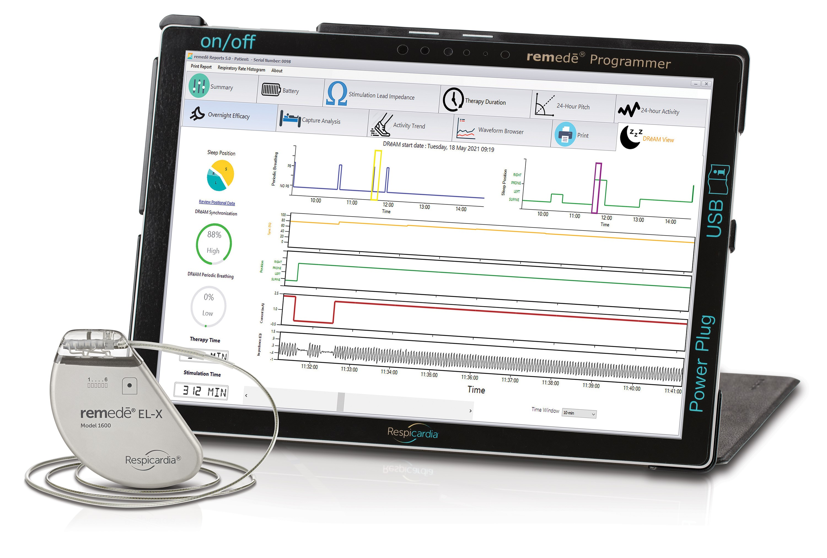
- 89% of patients had a reduction in the number of sleep apnea events⁴
- 78% of patients had an improvement in quality of life⁴
- 95% of patients reported they would “elect to have the medical procedure again”⁴
- Patients treated with remedē® System demonstrated clinically significant reduction in daytime sleepiness^{4,5}

DIAGNOSING CENTRAL SLEEP APNEA
CSA symptoms can be subtle and often overlap with co-existing symptoms that occur from other causes such as chronic heart failure, atrial fibrillation, and stroke. To diagnose CSA, a physician will prescribe a home or in-lab sleep study to determine whether the sleep disturbance results from inappropriate signals from the brain (CSA) or an airway blockage (obstructive sleep apnea, or OSA).

The remedē System received U.S. Food and Drug Administration (FDA) approval in 2017.

CONTACT US

<INSERT IMPLANTING PHYSICIAN(S)
NAME(S), CONTACT INFORMATION &
PHOTOGRAPH(S)>

REFERENCES

- Abraham, et al. Cardiac Failure Review 2018;4(1):50–3. DOI: https://doi.org/10.15420/cfr.2018:9:1
- Khayat et al. 2015;36:1463-9 Eur Heart J
- Khayat et al. J Card Fail 2012;1 8:534-540
- Costanzo, M. R., Ponikowski, P., Javaheri, S., et al. Sustained Twelve Month Benefit of Phrenic Nerve Stimulation for Central Sleep Apnea. The American Journal of Cardiology. 2018; DOI:10.1016/j.amjcard.2018.02.022.
- Costanzo M, et al. Transvenous neurostimulation for central sleep apnea: a randomized controlled trial. The Lancet. 2016; 388: 974-82.

The remedē® System

The remedē® system is indicated for moderate to severe Central Sleep Apnea in adult patients.
Your doctor will need to evaluate your condition to determine if the remedē system is right for you. The remedē system is MR Conditional but conditions apply. Please make sure that your physician knows about the conditions and precautions to ensure safety, which can be found in the remedē system MRI guidelines manual. You should not have the remedē System implanted if you have an infection and you will not be able to have diathermy (special heat therapies) after implantation. The remedē System may be used if you have another stimulation device such as a heart pacemaker or defibrillator; special testing will be needed to ensure the devices are not interacting.
As with any surgically implanted device, there are risks related to the surgical procedure itself which may include, but are not limited to, pain, swelling, and infection.
Once the therapy is turned on, some patients may experience discomfort from stimulation and/or from the presence of the device. The majority of these events are resolved either on their own or by adjusting the therapy settings. The remedē system may not work for everyone. There are additional risks associated with removing your system. If you and your doctor decide to remove the system, another surgery will be required.
Be sure to talk with your doctor so that you thoroughly understand all of the risks and benefits associated with the implantation of the remedē System. Rx only. For further information, please visit remede.zoll.com, call +1-952-540-4470 or email info@remede.zoll.com.
The remedē® System, remedē® EL System, and remedē® EL-X System have received FDA approval. The remedē® System model 1001 has received CE Mark approval.

Copyright © 2021 ZOLL Medical Corporation. All rights reserved. Respicardia and remedē are registered trademarks of ZOLL Respicardia, Inc. in the United States and/or other countries. ZOLL is a registered trademark of ZOLL Medical Corporation in the United States and/or other countries.

MKT1624, Rev C

